RAJALAKSHMI ENGINEERING COLLEGE

RAJALAKSHMI NAGAR, THANDALAM – 602 105



AD23632 - Framework for Data and Visual Analytics
LABORATORY NOTEBOOK

NAME:

YEAR/ BRANCH / SECTION: 3rd Yr / AIML REGISTER NO:
SEMESTERS: 5TH SEMESTER ACADEMIC YEAR: 2026-2027

RAJALAKSHMI ENGINEERING COLLEGE (AUTONOMOUS)

RAJALAKSHMI NAGAR, THANDALAM 602 105 BONAFIDE CERTIFICATE

NAME

REGISTER NO

ACADEMIC YEAR 2026-27 SEMESTER- V BRANCH: B.Tech - AIML

This Certification is the Bonafide record of work done by the above student in the AD23632 - Framework for Data and Visual Analytics Laboratory during the year 2026 2027.

Signature of Faculty -in Charge

Submitted for the Practical Examination held on

Internal Examiner External Examiner

INDEX

EXP NO | EXPERIMENT TITLE |     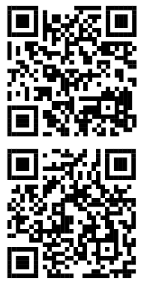  QR CODE | SIGN
1 | Setting up the python environment and libraries in Jupyter notebook | 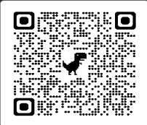
2 | EDA- Data Import and Export | 
3 | EDA- Data Cleaning | 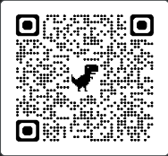
4 | EDA- Data Inspection and Analysis using pandas | 
5 | EDA- Data Visualization with matplotlib | 
6 | Data Visualization using Power Bi | 
7 | Data Visualization using Tableau | 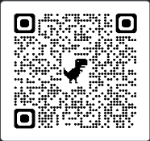
8 | Mini Project – Retail Sales Data Analysis Dashboard using matplotlib, Power Bi and Tableau | 

